NAME: S. DHARANI
REG NO: 192472364
COURSE CODE: DSA0401
NUMPY / PANDAS ANALYSIS – QUESTIONS AND ANSWERS
QUESTION 13: WORD FREQUENCY IN A TEXT FILE
AIM:
To read a text file and calculate the frequency of each word.
ALGORITHM:
1. Import Counter and re.
2. Open and read the text file.
3. Convert text to lowercase.
4. Extract words using a regular expression.
5. Count and display word frequencies.
CODE:
from collections import Counter
import re
with open("sample_text.txt", "r") as file:
text = file.read().lower()
words = re.findall(r"\b[a-z]+\b", text)
frequency = Counter(words)
for word, count in frequency.items():
print(word, ":", count)
INPUT:
sample_text.txt: Python is easy. Python is useful.
OUTPUT:
python : 2
is : 2
easy : 1
useful : 1
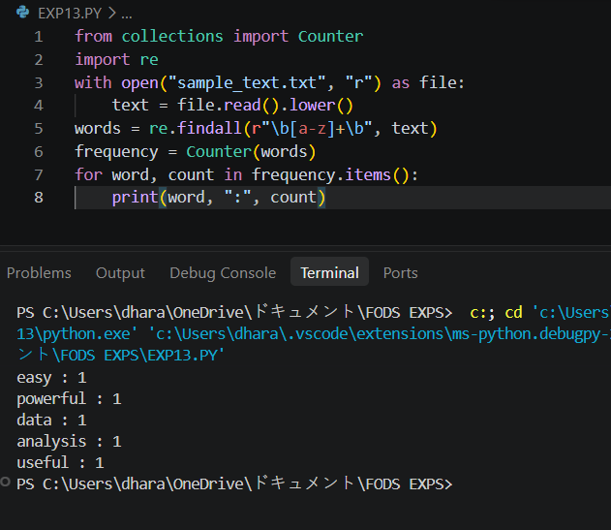
RESULT:
Word frequency was calculated successfully.
NOTE: Keep sample_text.txt in the same folder as the Python program.

